Impact Description Template

Our clients find that changing the term “job description” to “impact description” makes a significant positive difference. It helps both your team and your candidates to understand that every role at your company exists to impact the organization in some way. Our roles make a difference, move the needle, change the game.

Here are some of the items we recommend including in an impact (formerly known as job) description.

Who We Are (company mission, vision, values)

Who You Are (describe who a successful fit is)

Why This Role Matters (how the role impacts others—both internally and externally)

Who Your External and Internal Customers Are And How This Role Delivers Value To Them

Responsibilities

Requirements

Performance Metrics/KPIs For This Role

Potential Career Path (possible roles this role could evolve into, job skills and leadership skills)

Leadership Level of Role
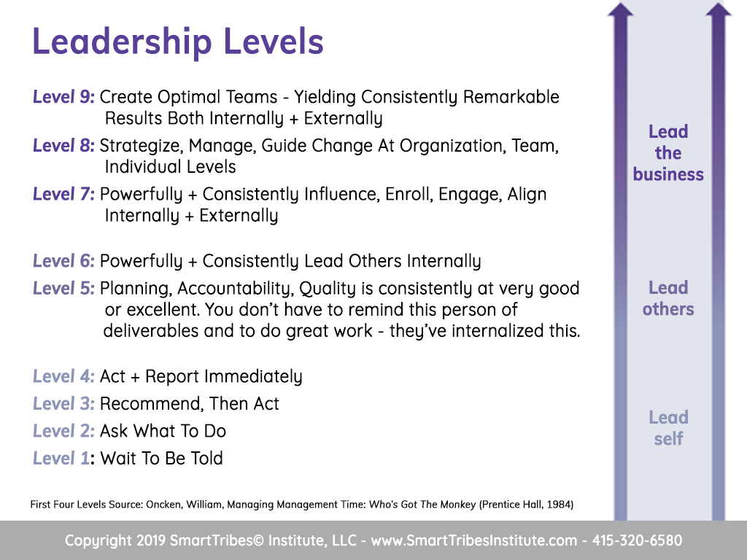

Learning and Development Opportunities

Compensation

